Chapter 1
- Introduction
The Internet of Things is connecting everyday intelligently to the Internet to enable communication between things and people. The devices can be any objects like smart-phones, Internet TVs, sensors, electronic devices, etc. For the objects to collect and exchange data electronics, software, sensors, and network connectivity are embedded into them. With increased in level of sophistication in basic appliances and increasing concerns for environmental sustenance demands for development of a smart system which is self-aware of its' surroundings and can analyze and respond with its own discretion without needing the aid of a human factor, called Automated systems. The proposed system focuses on the development of home automation system based on internet of things which allows the user to automate all the devices and appliances of home and merge them to provide seamless control over every side of their home. The data can be used to predict the user’s behavior custom with the development of a machine learning algorithm, and then the prediction results can be employed to enhance the intelligence of a smart home system. The designed system not only gives the sensor data but also process it according to the requirement, for example switching on the light when it gets dark and it allows the user to control the household devices from anywhere. The cloud is used to send the sensor data through wi-fi module and then a decision tree is implemented which decides the output of the electronic devices also, it is used to achieve the power control and local data exchanging which provide the user interface, store all the information corresponding to the specific house, and query the function information of an individual home appliance.
  - Literature Survey
- Title: Internet of Things based Home Automation System.
Author: Soumya S, Malini Chavali, Shuchi Gupta, Niharika Rao
Work implemented
This paper presents a home automation system based on internet of things which works successfully by connecting various appliances and providing the user remote control of the lighting system of their home. The objective is accomplished by using a Raspberry Pi which is connected to different sensors and run by a python program. The lights are programmed to turn off automatically if there is no one inside the room or if a person enters the room but the room is bright. JavaScript application is used to control the relay from anywhere. The proposed system is flexible, cost-effective and energy efficient. This system functions on its own as well as can be controlled from anywhere with the help of program code.
Fig 1.1.1.1: Architecture of the proposed system
Limitation
As the code is written in Node JS the problem is that the Application Programming Interface (API) keeps on changing at frequent intervals and does not remain stable.
The codes tend to become clumsy and the programmers must depend on the nested calls.
- Title: Enhanced Home Automation System using the Internet of Things.
Author: S L S Sri Harsha, S Chakrapani Reddy, Prince Mary S
Work implemented
This paper presents a home automation system based on internet of things which works successfully by connecting various appliances and providing the user remote control of the lighting system of their home. The objective of developing this model is to create a home automation system which interacts with the user through various push notifications based on concerned parameters which are also eco-friendly. This System uses a wide array of sensors paired with an application to visualize the sensor data and issue commands to the Home Automation and prompts the user to take appropriate action or initiates a sequence to handle the situation. HAS monitors general household activities such as controlling the lighting, atmospheric conditions, checking the integrity of gates and doors and so forth to provide a safe and comfortable environment for the user to live in.
Fig 1.1.2.1: System Block Diagram
- Title: IoT base Smart Home Appliances by using Cloud Intelligent Tetris Switch
Author: Ming-Shen Jian, Jun-Yi Wu, Jing-Yan Chen, Yue-Jyun Li, Hao-Yi Xu
Work Implemented
In this system, the cloud Intelligent Tetris Switch is used to achieve the local information exchanging and power control exchanging. The Cloud Intelligent Tetris Switch is the extension of the power line. Based on the embedded system module, each socket of the Switch can be individually controlled. In addition to the manual operation, users can use mobile application or browser to remotely control each socket. It means that each home appliance can be powered on/off remotely according to the command given by the user. Moreover, the Cloud Intelligent Tetris Switch with the embedded system module should connect to the Internet. The Bluetooth, Zigbee, or Wi-Fi is available for communication between Cloud Intelligent Tetris Switch and home appliances / remote home service server. In other words, the communication and data exchanging are achieved.
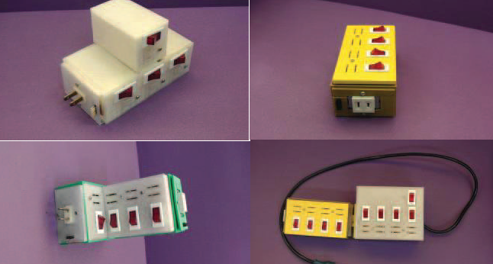
Fig 1.1.3.1: The dynamic extension of Cloud Intelligent Tetris Switch
Limitation
For home central server, to dynamically identify each home appliance for executing the same function or service is not possible.
- Title: Sensors in Smart Homes for Independent Living of the Elderly
Author: Pireh Pirzada, Neil White, Adriana Wilde
Work Implemented
This system provides a safe living environment which can identify and predict problems by monitoring the activities of the inhabitants. To handle continuous streams of the data a system is required. Such a system can extract the data by using appropriate algorithms and thus allowing the remote monitoring of the health at a high level. The implementation requires the use of appropriate sensing technologies, identification of ADLs, data pre-processing techniques and machine learning algorithms. This is challenging as there will be many individuals such a system must be able to personalize individual needs. The implementation and design of a platform to smartly monitor the health condition of the elder person using sensor data from a smart home, through an interactive user interface which is user-friendly and multiplatform. This proof-of-concept used off-line data, with the view to extend to real-time data collection in the future, which could then be used to inform support providers remotely.
Fig 1.1.4.1: Architecture of Smart Home Application
  - Limitation of the current work
- When the weather is unpredictable it won't give an accurate result.
- During the heavy cyclone, IoT device may not work.
- If there is no Internet connection at either end, we need to devise a backup plan for the system.
- Some appliances might not be compatible with the system.
  - Problem Definition
The IoT devices can be controlled manually by the user but, what if it can be controlled through the sensor data? A decision tree can be implemented by sending the sensor data through the cloud.
  - Objectives
- To control the electronic devices automatically with the help of sensor data over the cloud.
- To develop a decision tree which is used to control the speed of the motor and control the intensity of the light.
- To analyze the data and the status of the home appliances continuously with the help of a decision tree.
- Provide a smart home at low cost.
  - Methodology
An Arduino Uno is connected to the sensors which are Humidity and Temperature. The data collected from the sensors is sent to the firebase cloud using Wi-Fi module. Then a JSON file if being created which contains the output of the sensors. This file is used to implement a decision tree. The output is then sent to the electronic devices like motor and LED light and they work accordingly. A 9V battery is used for supplying the power to the electronic devices.
  - Hardware and Software tools used
Hardware tools: Arduino Uno, ESP8266-01 - Wi-Fi Module, LM393 Humidity Sensor, LM35 Temperature Sensor, Jumper wires (connecting wires), Motor, LED strip, 9V battery.
Software tools: Arduino IDE, Blynk Android Application, Firebase.

Chapter 2
- Basic Theory
Home Automation Systems consist of several appliances (e.g. washing machine, dishwasher, oven, refrigerator, boiler) and other devices which are connected by a communication network. The various elements of the system share common resources (mainly electricity, but also water) to accomplish their specific tasks, according to user requirements. Since resources are limited (due to costs, contract rules or provider directives), competition between the elements of the system generates internal conflicts. Distributed or centralized control strategies must be implemented within the system, so to allocate limited resources while maximizing performances, using the information dispatched over the communication network and the computational resources the devices, or a dedicated unit of them, may have. From a control theory point of view, Home Automation Systems are very complex objects, characterized by the presence of components and constraints of different kinds, a distributed structure and a hybrid event/time-driven behavior. Although the market offers devices and solutions that allow to assemble sophisticated Home Automation Systems, efficient design techniques are far from being developed.

Chapter 3
- Tool Description
  - Hardware Tools
    - Arduino UNO
The Arduino Uno is a microcontroller board based on the ATmega328. It has 20 digital input/output pins (of which 6 can be used as PWM outputs and 6 can be used as analog inputs), a 16 MHz resonator, a USB connection, a power jack, an in-circuit system programming (ICSP) header, and a reset button. It contains everything needed to support the microcontroller; simply connect it to a computer (or appropriate wall power adapter) with a USB cable or power it with an AC-to-DC adapter or battery to get started.
The Uno differs from all preceding boards in that it does not use the FTDI USB-to-serial driver chip. Instead, it features an ATmega16U2 programmed as a USB-to-serial converter. This auxiliary microcontroller has its own USB bootloader, which allows advanced users to reprogram it.
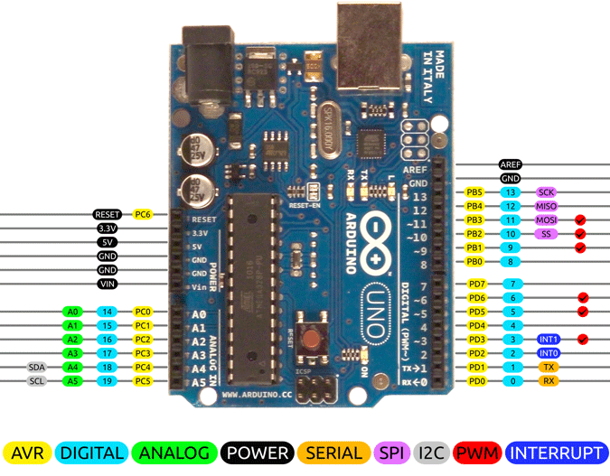
Fig 3.1.1.1: Arduino UNO embedded board with pin description

Digital Pins
In addition to the specific functions listed below, the digital pins on a microcontroller can be used for general purpose input and output via the pinMode(), digitalRead(), and digitalWrite() commands. Each pin has an internal pull-up resistor which can be turned off and on by using digitalWrite() (w/ a value of LOW or HIGH, respectively) when the pin is configured as an input. The maximum current per pin is 40 mA.
- Serial: 0 (RX) and 1 (TX). Used to transmit (TX) and receive (RX) TTL serial data. On the Arduino Diecimila, these pins are connected to the corresponding pins of the FTDI USB-to-TTL Serial chip. On the Arduino BT, these pins are connected to the corresponding pins of the WT11 Bluetooth module. On the Lilypad Arduino and Arduino Mini, they are intended for use with an external TTL serial module (e.g. the Mini-USB Adapter).
- External Interrupts 2 and 3. These pins can be configured to trigger an interrupt on a low value, a rising or falling edge, or a change in value. See the attachInterrupt() function for details.
- PWM: 3, 5, 6, 9, 10, and 11. Provide 8-bit PWM output with the analogWrite() function. On boards with an ATmega8, PWM output is available only on pins 9, 10, and 11.
- BT Reset: 7. (Arduino BT-only) Connected to the reset line of the Bluetooth module.
- SPI: 10 (SS), 11 (MOSI), 12 (MISO), 13 (SCK). These pins support SPI communication, which, although provided by the underlying hardware, is not currently included in the Arduino language.
- LED: 13. On the Diecimila and Lilypad, there is a built-in LED connected to digital pin 13. When the pin is HIGH value, the LED is on, when the pin is LOW, it's off.
Analog Pins
In addition to the specific functions listed below, the analog input pins support 10-bit analog-to-digital conversion (ADC) using the analogRead() function. Most of the analog inputs can also be used as digital pins: analog input 0 as digital pin 14 through analog input 5 as digital pin 19. Analog inputs 6 and 7 (present on the Mini and BT) cannot be used as digital pins.
- I2C: 4 (SDA) and 5 (SCL). Support I2C (TWI) communication using the Wire library.

Power Pins
- VIN: The input voltage to the Arduino board when it's using an external power source (as opposed to 5 volts from the USB connection or other regulated power sources). You can supply voltage through this pin, or, if supplying voltage via the power jack, access it through this pin. Note that different boards accept different input voltages ranges, please see the documentation for your board. Also, note that the LilyPad has no VIN pin and accepts only a regulated input.
- 5V: The regulated power supply used to power the Arduino and other components on the board. This can come either from VIN via an on-board regulator or be supplied by Universal Serial Bus or another regulated 5V supply.
- 3V3: (Diecimila-only) A 3.3-volt supply generated by the onboard FTDI chip.
- GND: Ground pins.
Other Pins
- AREF: Reference voltage for the analog inputs. Used with analogReference().
- Reset: Bring this line LOW to reset the Arduino UNO. Typically used to add a reset button to shields which block the one on the Arduino board.

    - ESP8266-01 - Wi-Fi Module
The Wi-Fi library for ESP8266 has been developed basing on ESP8266 SDK, using a naming convention and overall functionality philosophy of Arduino Wi-Fi library. Over time the wealth Wi-Fi features ported from ESP9266 SDK to esp8266 / Arduino outgrow Arduino Wi-Fi library and it became apparent that we need to provide separate documentation on what is new and extra.
Quick Start
To hook up ESP module to Wi-Fi (like hooking up a mobile phone to a hot spot), you need just a couple of lines of code.
Devices that connect to the Wi-Fi network are called stations (STA). Connection to Wi-Fi is provided by an access point (AP), that acts as a hub for one or more stations. The access point on the other end is connected to a wired network. An access point is usually integrated with a router to provide access from the Wi-Fi network to the internet. Each access point is recognized by an SSID (Service Set Identifier), that essentially is the name of the network you select when connecting a device (station) to the Wi-Fi.
ESP8266 module can operate as a station so we can connect it to the Wi-Fi network. It can also operate as a soft access point (soft-AP), to establish its own Wi-Fi network. Therefore, we can connect other stations to such ESP module. ESP8266 is also able to operate both in station and soft access point mode. This provides the possibility of building.
Fig 3.1.2.1: ESP8266-01 - Wi-Fi Module

    - LM35 Temperature Sensor
The LM35 series are precision integrated-circuit temperature devices with an output voltage linearly proportional to the Centigrade temperature. The LM35 device has an advantage over linear temperature sensors calibrated in Kelvin, as the user is not required to subtract a large constant voltage from the output to obtain convenient Centigrade scaling. The LM35 device does not require any external calibration or trimming to provide typical accuracies of ±¼°C at room temperature and ±¾°C over a full −55°C to 150°C temperature range. Lower cost is assured by trimming and calibration at the water level. The low-output impedance, linear output, and precise inherent calibration of the LM35 device make interfacing to readout or control circuitry especially easy. The device is used with single power supplies, or with plus and minus supplies. As the LM35 device draws only 60 µA from the supply, it has very low self-heating of less than 0.1°C in still air. The LM35 device is rated to operate over a −55°C to 150°C temperature range, while the LM35C device is rated for a −40°C to 110°C range (−10° with improved accuracy). The LM35-series devices are available packaged in hermetic TO transistor packages, while the LM35C, LM35CA, and LM35D devices are available in the plastic TO-92 transistor package. The LM35D device is available in an 8-lead surface-mount small-outline package and a plastic TO-220 package.
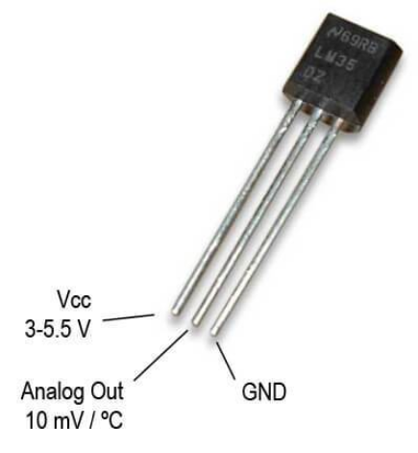
Fig 3.1.3.1: LM 35 Temperature Sensor

    - LM393 Humidity Sensor
The LM393 sensors are dual independent precision voltage comparators capable of single or split supply operation. They are designed to permit a common mode range−to−ground level with single supply operation. Input voltage specifications are as low as 2.0 mV which makes the device an excellent selection for many applications in automotive, client, and industrial electronics.
Features
- Very Low Current Drain Independent of Supply Voltage: 0.4 mA.
- Wide Single−Supply Range: 2.0 Vdc to 36 Vdc.
- Split−Supply Range: ±1.0 Vdc to ±18 Vdc.
- Low Input Bias Current: 25 nA.
- Low Input Offset Current: 5.0 nA.
- Differential Input Voltage Range Equal to Power Supply Voltage.
- Low Input Offset Voltage: 5.0 mV (max) LM293/393.
- Input Common Mode Range to Ground Level.
- Output Voltage Compatible with DTL, ECL, TTL, MOS, and CMOS Logic Levels.
- ESD Clamps on the Inputs Increase the Ruggedness of the Device without Affecting Performance.
- NCV Prefix for Automotive and Other Applications Requiring Unique Site and Control Change Requirements; AEC−Q100Qualified and PPAP Capable.
- These Devices are Pb−Free, Halogen Free/BFR Free and are RoHS Compliant.
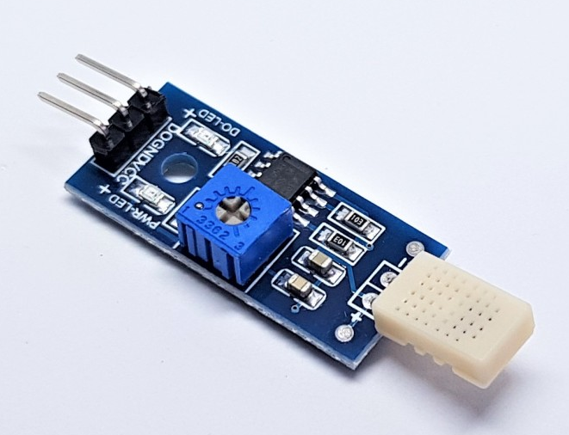
Fig 3.1.4.1: LM393 Humidity Sensor

    - Jumper Wires
A jump wire (also known as jumper wire, or jumper) is an electrical wire, or group of them in a cable, with a connector or pin at each end (or sometimes without them – simply "tinned"), which is used normally to interconnect the components of a breadboard or other prototype or test circuit, internally or with other components or equipment, without soldering. Individual jumper wires are fitted by inserting their end into the slots provided in an Arduino board, a breadboard, the header connector of a circuit board, or a piece of test equipment.
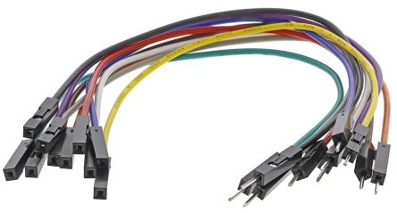
Fig 3.1.5.1: Jumper Wires
    - Motor
It is an electrical machine that converts electrical energy into mechanical energy. Most motors operate through the interaction between the motor's electric current and magnetic field in a wire winding to generate force in the form of rotation of a shaft. The motors are powered by direct current (DC) sources, like batteries, motor vehicles or rectifiers, or by alternating current (AC) sources, such an inverter, a power grid or an electrical generator. An electric generator is mechanically identical just like an electric motor, but operates in the reverse direction, changing mechanical energy into electrical energy.
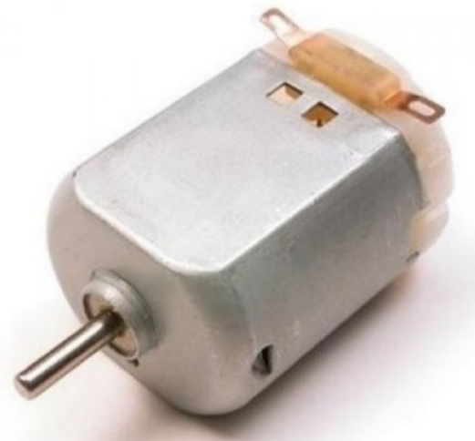
Fig 3.1.6.1: Electric Motor
  - Software Tools
    - The Arduino IDE
The Arduino IDE is a platform which provides an environment for most Arduino-based projects. The top menu bar has the standard options, including “File” (new, load save, etc.), “Edit” (font, copy, paste, etc.), “Sketch” (for compiling and programming), “Tools” (useful options for testing projects), and “Help”. In the middle section of the IDE, there is a simple text editor that where you can write the program code. The bottom section of the IDE is for an output window which is used to see the status of the compilation, how much memory has been used if any errors were found within the program, and various other useful messages.
Projects that are created using Arduino IDE are called sketches, and such sketches are usually written in a cut-down version of C++ (several C++ features are not included). Because programming an Arduino i.e. a micro-controller is somewhat different from programming a computer, there are several device-specific libraries (e.g., changing pin modes, output data on pins, reading analog values, and timers). This may confuse the users who think Arduino is programmed in an “Arduino language.” However, the Arduino is, in fact, programmed in C++. It just uses unique libraries for the device.
Fig 3.2.1.1: Arduino IDE
    - Blynk Android Application
Blynk Application is a new platform that enables you to quickly build interfaces for controlling and monitoring the hardware projects from iOS and Android devices. After downloading the Blynk, the user will be able to create a project dashboard and arrange buttons, sliders, graphs, and other widgets onto the screen. Using the widgets, the user can turn buttons on and off or display data from sensors.
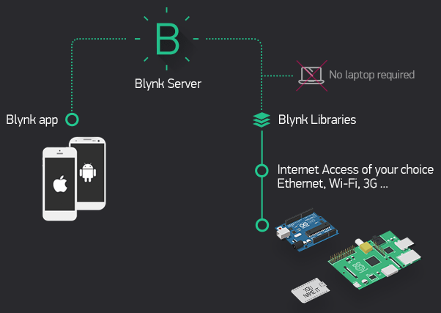
Fig 3.2.2.1: The Architecture of the Blynk Application
This application was designed for the Internet of Things. It can control hardware remotely, it can display sensor data, it can store the data, visualize it and do many other cool things.
There are three major components in the platform:
- Blynk App: which allows the user to create amazing interfaces for the projects using various widgets that is provided within the application.
- Blynk Server: which is responsible for all the communications between the smartphone and hardware. The user can use the Blynk Cloud or run the private Blynk server locally. It’s an open-source, could easily handle thousands of devices and can even be launched on an Arduino UNO or Raspberry Pi.
- Blynk Libraries: for all the popular hardware platforms - it enables the communication with the server and process all the incoming and outcoming commands.
    - Firebase
Firebase is a web app development and mobile platform that provides the developers with plenty of tools and services to help them develop high-quality apps, grow their user base and earn more profit. Firebase provides cloud storage which is a powerful, simple, and cost-effective object storage service built for Google scale. The Firebase SDKs for Cloud Storage add Google security to file uploads and downloads for the Firebase application, regardless of network quality. The user can use the SDKs to store the images, audio, video, or other user-generated content. On the server, the user can use Google Cloud Storage, to access the same files.
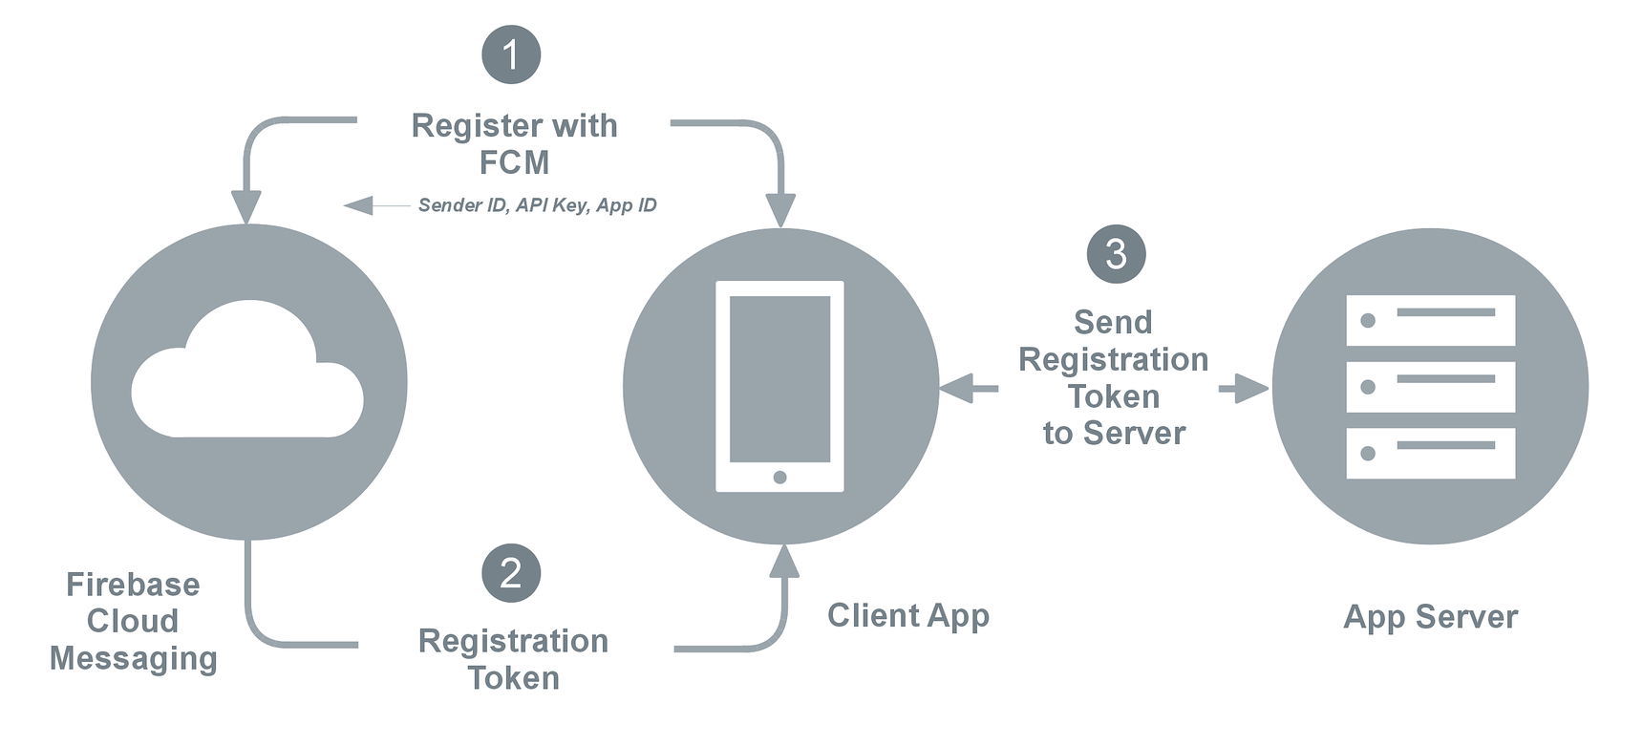
Fig 3.2.3.1: Firebase Cloud Functioning
Firebase SDKs were used by the developers for Cloud Storage to upload and download files directly from clients. If the network connection is poor, the user can retry the operation right where it left off, saving users time and bandwidth. Cloud Storage stores the files in the Cloud Storage bucket, making them accessible through both Google and Firebase Cloud. This allows the user, flexibility to upload and download files from mobile clients via the Firebase SDKs and do server-side processing such as image filtering or video transcoding using Google Cloud Platform. Cloud Storage scales automatically, meaning that there's no need to migrate to any other provider. Learn more about all the benefits of our integration with Google Cloud Platform.

